**Project Design Phase-II**

**Technology Stack (Architecture & Stack)**

|  |  |
| --- | --- |
| Date | 27 June 2025 |
| Team ID | LTVIP2025TMID59978 |
| Project Name | SmartSDLC – AI-Enhanced Software Development Lifecycle |
| Maximum Marks | 4 Marks |

**Technical Architecture:**

The Deliverable shall include the architectural diagram as below and the information as per the table1 & table 2

**Example:** **AI-Augmented SmartSDLC for Agile Software Teams**   
**Reference:** <https://aws.amazon.com/blogs/apn/transforming-the-software-development-lifecycle-sdlc-with-generative-ai/>

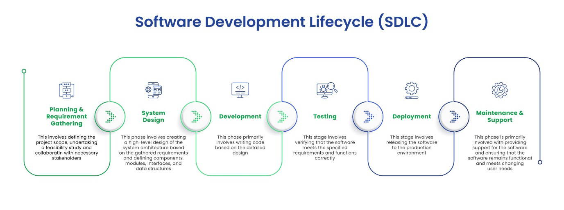

**Table-1 : Components & Technologies:**

|  |  |  |  |
| --- | --- | --- | --- |
| **S.No** | **Component** | **Description** | **Technology** |
|  | User Interface | Web dashboard for managing projects and viewing AI insights | React.js, HTML5, CSS3 |
|  | Application Logic-1 | AI-based requirement analysis and document parsing | Python (Flask), SpaCy, NLTK |
|  | Application Logic-2 | Transcribe voice meetings for task logging | IBM Watson Speech to Text |
|  | Application Logic-3 | Chatbot support for answering SDLC queries | IBM Watson Assistant |
|  | Database | Stores user data, project metadata, task logs | MongoDB (NoSQL), MySQL |
|  | Cloud Database | Cloud-hosted database for real-time syncing | IBM Cloudant |
|  | File Storage | Code files, generated reports, documentation | IBM Block Storage, Local Filesystem |
|  | External API-1 | GitHub integration for CI/CD & code analysis | GitHub REST API |
|  | External API-2 | Integration with Jira for agile boards and ticketing | Jira API |
|  | Machine Learning Model | Predict bugs, generate code suggestions, and estimate effort | TensorFlow, OpenAI Codex, Scikit-learn |
|  | Infrastructure (Server / Cloud) | Cloud-native deployment with CI/CD pipeline | Kubernetes, Docker, IBM Cloud Foundry, Jenkins |

**Table-2: Application Characteristics:**

|  |  |  |  |
| --- | --- | --- | --- |
| **S.No** | **Characteristics** | **Description** | **Technology** |
|  | Open-Source Frameworks | Frameworks used for backend, frontend, and ML | Flask, React.js, TensorFlow, Kubernetes |
|  | Security Implementations | Role-based access, data encryption, secure APIs | JWT, SHA-256, OAuth2.0, HTTPS, IAM Policies |
|  | Scalable Architecture | Microservice-based deployment for each SDLC phase | Kubernetes, Docker |
|  | Availability | Ensured with replicated services and cloud load balancer | NGINX, IBM Cloud Load Balancer, Multi-Zone Setup |
|  | Performance | Use of Redis for caching, Celery for background tasks, CDN for static files | Redis, Celery, Cloudflare CDN |

**References:**

<https://developer.ibm.com/patterns/ai-powered-devops/>

<https://www.ibm.com/cloud/cloudant>

<https://www.ibm.com/cloud/watson-speech-to-text>

<https://docs.github.com/en/rest>

<https://developer.atlassian.com/cloud/jira/platform/rest/v3/>

<https://c4model.com/>

<https://www.ibm.com/cloud/architecture>